1x2(2x2) PM Fusion Coupler

1. Features
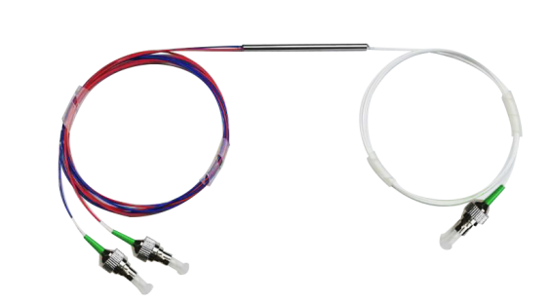

- Low Insertion Loss
- High Power
- High Stability and Reliability

2. Applications
- Coherent communication
- Fiber Optic Gyroscope
- Fiber Sensor

3. Specifications
Parameters | Unit | Value
Operating Wavelength | nm | 1310
Operating Bandwidth | nm | ±15
Insertion Loss | dB | ≤14.4/0.8 (5/95)
Excess Loss at 23℃ | dB | ≤0.4
Extinction Ratio | dB | ≥22
Return Loss | dB | ≥50
Directionality | dB | ≥50
Power | W | 1
Operating Temperature | ℃ | -5~+65
Storage Temperature | ℃ | -40～+80
Port Type | / | 1x2
Fiber Type | / | PM 13-U25D
Fiber Length | m | 1.0±0.1m, others on request
Connector | / | FC/APC, others on request
Package Dimension | mm | φ3.0x54 (900μm Loose Tube )

4．Package Dimension
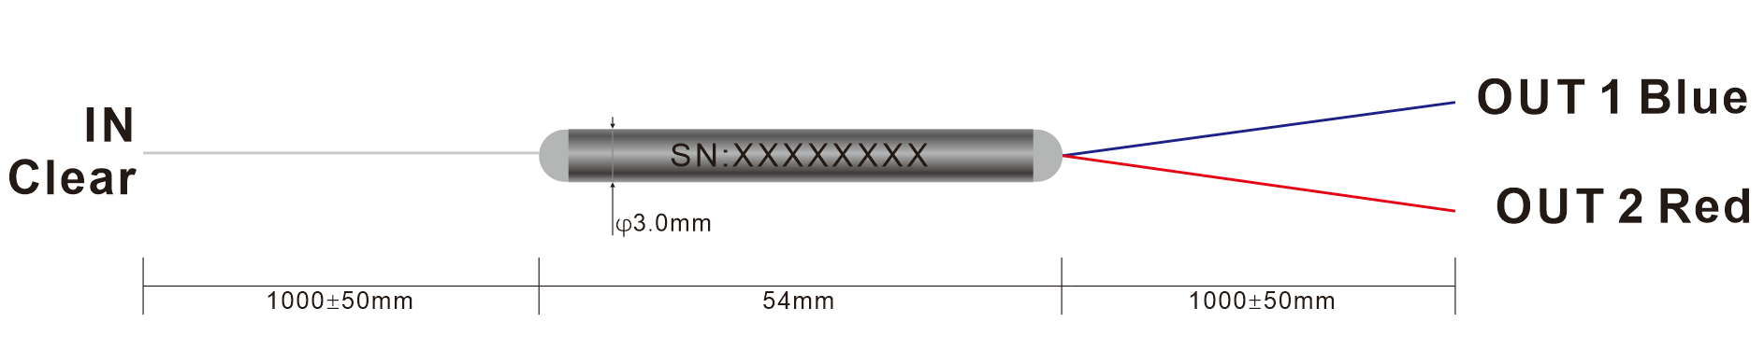

5. Ordering information
Couper | - | XXX | XXX | XX | XXX | XX | XX | - | X | X
 |  | Port NO | Wavelength | Splitting Ratio | Modules type | Fiber Type | Fiber Length |  | Com  connector | Port  Connector
PM Fusion=  PM FBT |  | 12=1X2 | 131=1310nm | 50=50/50 | ST1=Ф3.0X45 | 02=250um fiber | 10=1.0m |  | 0=None | 0=None
PM Fusion=  PM FBT |  | 22=2X2 | 148=1480nm | 90=90/10 | ST2=Ф3.0X54 | 09=0.9mm Tube | XX=Customized |  | 1=FC/UPC | 1=FC/UPC
PM Fusion=  PM FBT |  |  | 155=1550nm | 99=99/01 | SB=90 X20 X10 | 20=2.0mm Tube |  |  | 2=FC/APC | 2=FC/APC
 |  |  | 980=980nm | 95=95/5 | XX=Customized | 30=3.0mm Tube |  |  | 3=SC/UPC | 3=SC/UPC
 |  |  | 106=1064nm |  |  | XX=Customized |  |  | 4=SC/APC | 4=SC/APC
 |  |  | 780=780nm |  |  |  |  |  | 5=LC/UPC | 5=LC/UPC
 |  |  |  |  |  |  |  |  | 6=LC/APC | 6=LC/APC
 |  |  |  |  |  |  |  |  | X=Customized | X=Customized

Part Number | Product Description
PMFBT-1213195ST20910-22(S) | 1*2 PM Fusion Coupler, Splitting Ratio 95/5, Steel Tube type,  PM13-U25D fiber with 0.9mm Hytrel White Tube, fiber Length 1m (with connector), connector FC/APC, connector key is aligned to slow axis, fast axis blocked.

